**Capital University of Science & Technology**

**Term Project Proposal**

Department of Electrical and Computer Engineering

|  |  |  |  |
| --- | --- | --- | --- |
| **Project Title** | | **Library Fine Calculator Based on Late Days** | |
| **Course Title** | | **CYG-1611** | |
| **Sr. No.** | **Student Name** | | **Registration Number** |
| **01.** | Adeel Haider Zulqarnain | | BCPE-243042 |
| **02.** | Muhammad Hannan Faisal | | BCPE-243044 |

**Idea:**

The **Library Fine Calculator** is a C++ program that allows users to input the due date and return date of a borrowed book, calculates the number of late days, and computes the total fine based on a predefined rate (e.g., 0.4$ per day).

**Objective:**

* 1. **User Input:** Prompt for due date and return date.
  2. **Date Validation:** Ensure dates are valid and logical.
  3. **Fine Calculation:** Calculate late days and total fine.
  4. **Display Results**: Show late days and total fine to the user.
  5. **Error Handling:** Manage invalid inputs with informative messages.
  6. **Repeat Option**: Allow multiple calculations in one session.

**Application:**

1. **Library Management Systems:** Automate fine calculations in library software.
2. **Educational Institutions:** Help schools and universities manage library resources.
3. **Public Libraries:** Provide patrons with easy fine calculations for overdue books.
4. **Mobile Applications:** Allow users to check fines and due dates on-the-go.
5. **Online Library Services:** Enable users to manage accounts and calculate fines remotely.
6. **Library Staff Training:** Train staff on fine policies and calculations

**Block Diagram:**

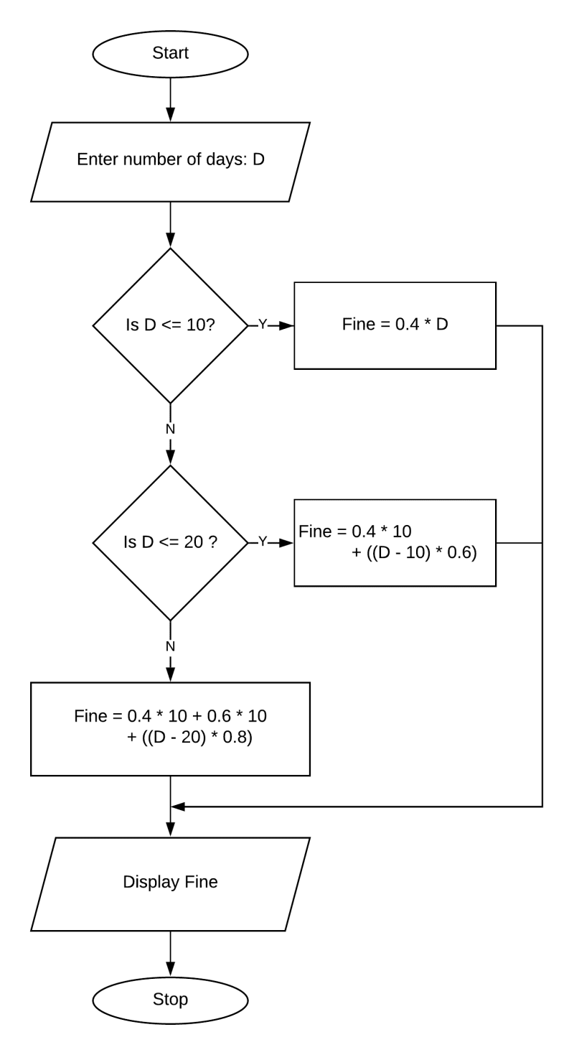

**Instructor Remarks:**

**Student 1 Signature: __________________**

**Student 2 Signature: __________________**

**Instructor’s Signature: __________________ Date: __________________**